Spark Assignment – 2 (Movie Data Analysis) Documentation

Tools used:
- GCP – Managed Apache Spark
- Jupyter Lab – Comes with Managed Apache Spark
Files Attached:
- Spark_Assignment_2_Documentation.docx
- Assignment_2_Solution.ipy
Over Process I followed:
Step 1:
I uploaded all the three csv files given to us as the raw data for this assignment in Hadoop cluster.
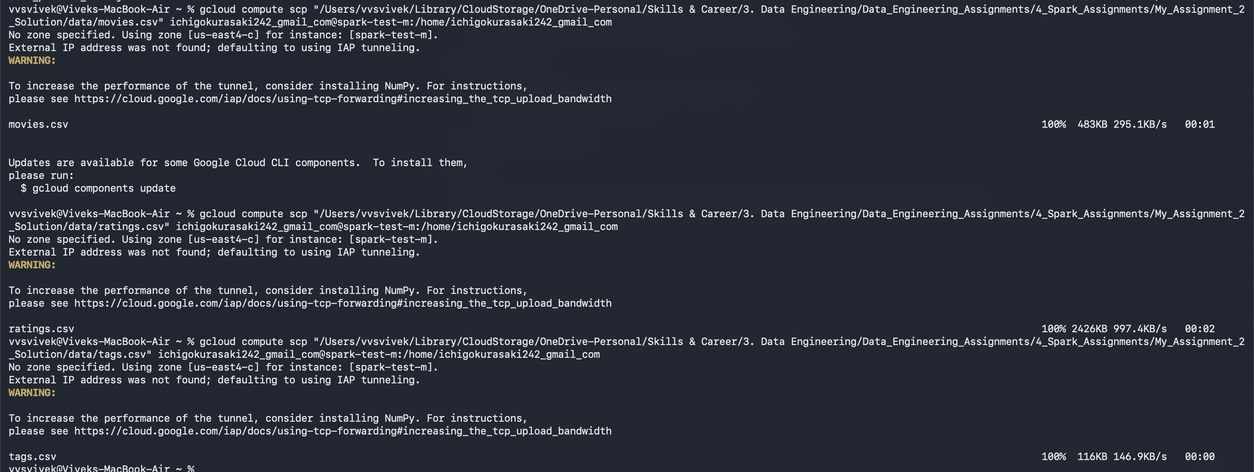
Step 2:
Once the files were uploaded, I moved these files in HDFS and then created dataframe out of each of these files.
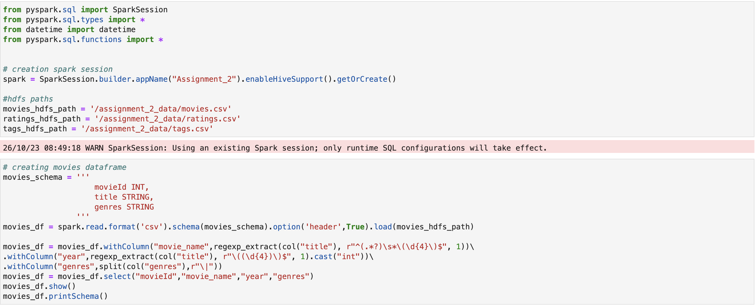
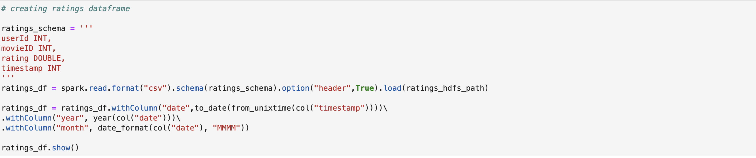
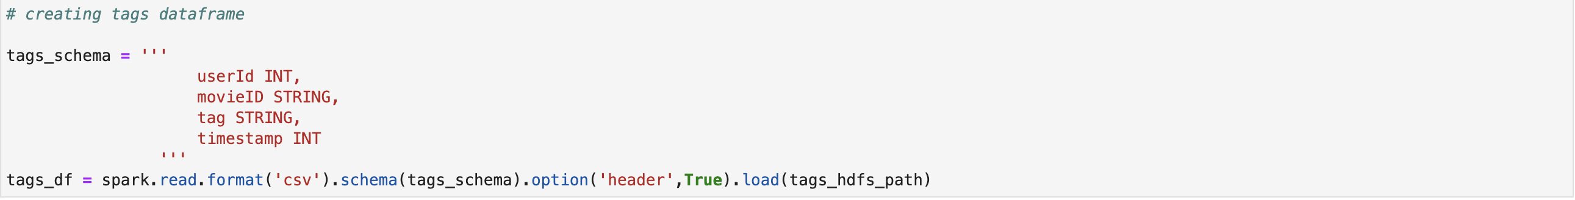
Step 3:
Once these dataframes were created, a created temporary views out them so that I could easily do the data analysis using spark SQL. Although I have also made sure in some of the question I have also written the pyspark code to show how we can do the same analysis using pyspark also. For example:
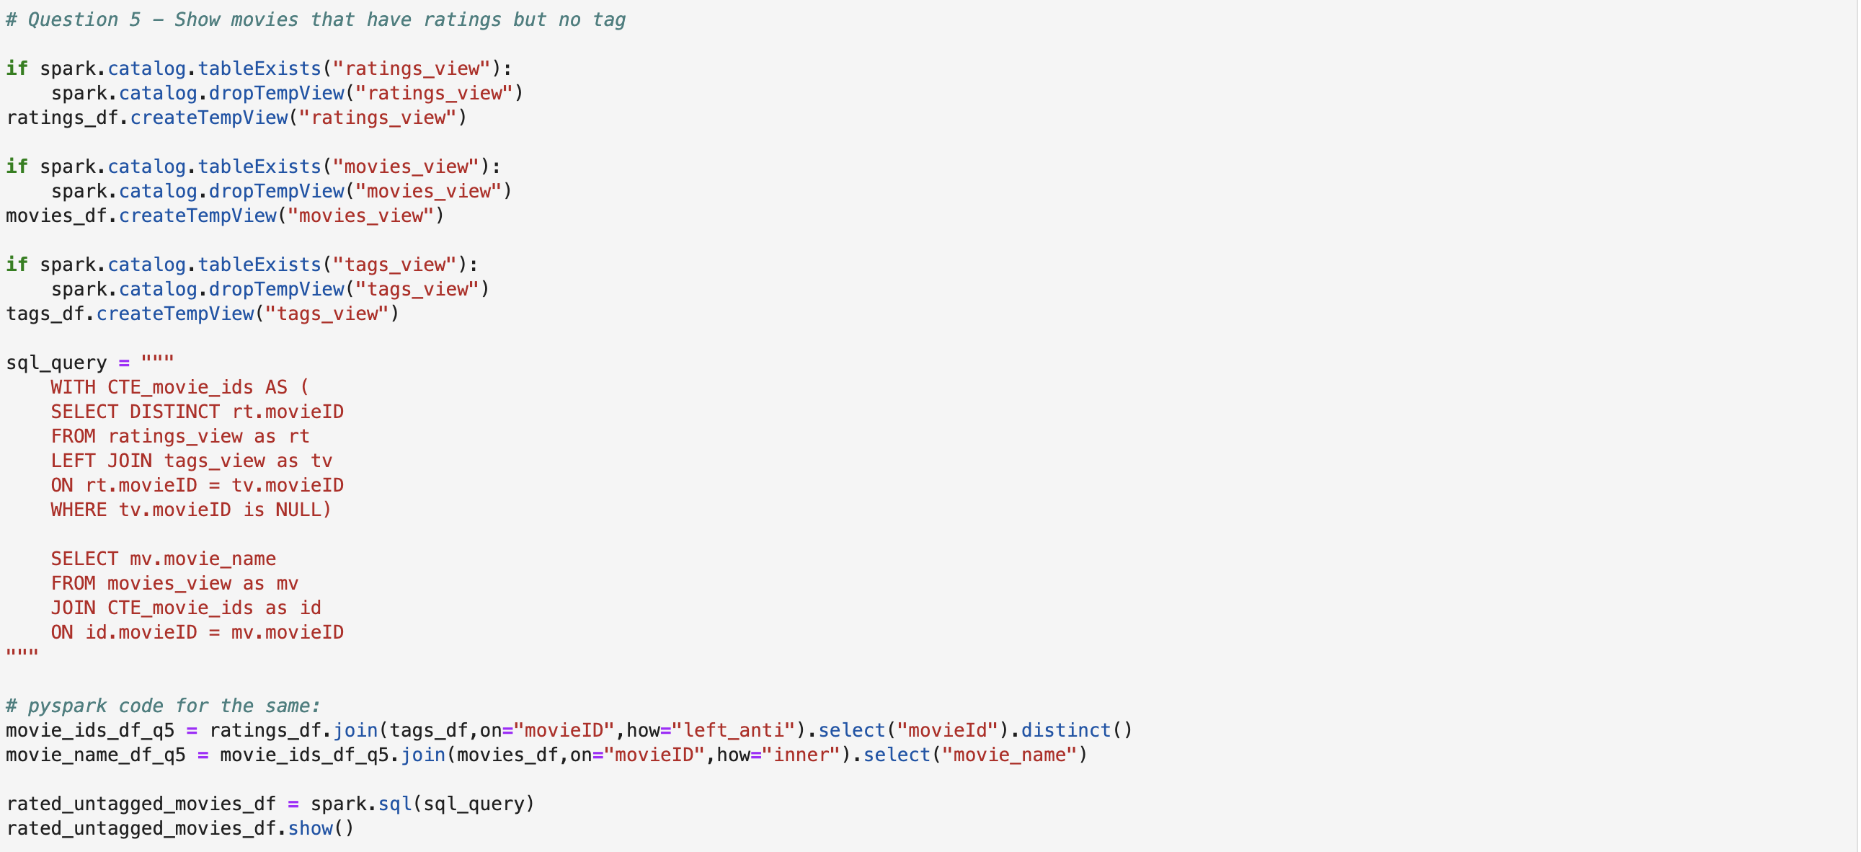
Step 4:
I have made sure that output of each analysis was written to HDFS. You can see the location of each output in the HDFS name node UI screenshot below:
